Title: Signal Processing and Machine Learning for Brain-Computer Interfaces (3 hours)
Speakers: Dongrui Wu, Zhaohong Deng, and Kup-Sze Choi

Affiliations:
School of Automation, Huazhong University of Science and Technology, Wuhan, China (Wu)
School of Digital Media, Jiangnan University, Wuxi, China (Deng)
School of Nursing, Hong Kong Polytechnic University, Hong Kong, China (Choi)
Emails: drwu@hust.edu.cn, dzh666828@aliyun.com, kschoi@ieee.org

Abstract:
Brain-computer interfaces (BCIs) can use brain signals such as the scalp electroencephalogram (EEG) to enable people to communicate or control external devices. Thus, they can help people with devastating neuromuscular disorders such as amyotrophic lateral sclerosis, brainstem stroke, cerebral palsy, and spinal cord injury. However, there are still many challenges in their transition from laboratory settings to real-life applications, including the reliability and convenience of the sensing hardware, and the availability of high-performance and robust algorithms for signal analysis and interpretation.
This tutorial will focus on the latter challenge. We will introduce the basic concept of BCIs, their applications, and some recent advances in signal processing and machine learning for BCIs, including:
- Signal processing: spatial and temporal filtering
- Feature extraction: Riemannian geometry features
- Machine learning: active learning, deep learning, transfer learning, ensemble learning, fuzzy logic, etc.
- Their applications in both BCI classification and regression problems.

Related Publications:
1. D. Wu, B. J. Lance, V. J. Lawhern, Stephen Gordon, Tzyy-Ping Jung and Chin-Teng Lin, “EEG-Based User Reaction Time Estimation Using Riemannian Geometry Features”, IEEE Transactions on Neural Systems and Rehabilitation Engineering, accepted.
2. D. Wu, J-T King, C-C Chuang, C-T Lin and T-P Jung, "Spatial Filtering for EEG-Based Regression Problems in Brain-Computer Interface (BCI)," IEEE Transactions on Fuzzy Systems, accepted.
3. D. Wu, V. Lawhern, S. Gordon, B. Lance and C-T Lin, "Driver Drowsiness Estimation from EEG Signals Using Online Weighted Adaptation Regularization for Regression (OwARR)," IEEE Transactions on Fuzzy Systems, 2017, in press.
4. D. Wu, "Online and Offline Domain Adaptation for Reducing BCI Calibration Effort," IEEE Transactions on Human-Machine Systems, vol. 47, no. 4, pp. 550-563, 2017.
5. D. Wu, V. Lawhern, D. Hairston and B. Lance, "Switching EEG Headsets Made Easy: Reducing Offline Calibration Effort Using Active Weighted Adaptation Regularization," IEEE Transactions on Neural Systems and Rehabilitation Engineering, 24(11), pp. 1125-1137, 2016.
6. Marathe, V. Lawhern, D. Wu, D. Slayback and B. Lance, "Improved Neural Signal Classification in a Rapid Serial Visual Presentation Task using Active Learning," IEEE Transactions on Neural Systems and Rehabilitation Engineering, 24(3), pp. 333-343, 2016.
7. D. Wu, B. Lance, and T.D. Parsons, "Collaborative Filtering for Brain-Computer Interaction Using Transfer Learning and Active Class Selection," PLoS ONE, 2013.
8. D. Wu, "Active Semi-supervised Transfer Learning (ASTL) for Offline BCI Calibration," IEEE Int'l. Conf. on Systems, Man and Cybernetics, Banff, Canada, 2017.
9. D. Wu, V. Lawhern, S. Gordon, B. Lance and C-T Lin, "Offline EEG-Based Driver Drowsiness Estimation Using Enhanced Batch-Mode Active Learning (EBMAL) for Regression," IEEE Int'l. Conf. on Systems, Man and Cybernetics, pp. 730-736, Budapest, Hungary, 2016.
10. D. Wu, V. Lawhern, S. Gordon, B. Lance and C-T Lin, "Spectral Meta-Learner for Regression (SMLR) Model Aggregation: Towards Calibrationless Brain-Computer Interface (BCI)," IEEE Int'l. Conf. on Systems, Man and Cybernetics, pp. 743-749, Budapest, Hungary, 2016.
11. Yizhang Jiang, Zhaohong Deng, Fu-Lai Chung, Guanjin Wang, Pengjiang Qian, Kup-Sze Choi, Shitong Wang, “Recognition of Epileptic EEG Signals Using a Novel Multiview TSK Fuzzy System,” IEEE Trans. Fuzzy Systems, vol. 25, no. 1, pp. 3-20, 2017.
12. Changjian Yang, Zhaohong Deng, Kup-Sze Choi, Shitong Wang, “Takagi-Sugeno-Kang Transfer Learning Fuzzy Logic System for the Adaptive Recognition of Epileptic Electroencephalogram Signals,” IEEE Trans. Fuzzy Systems, vol. 24, no. 5, pp. 1079-1094, 2016.
13. Changjian Yang, Zhaohong Deng, Kup-Sze Choi, Yizhang Jiang, Shitong Wang, “Transductive domain adaptive learning for epileptic electroencephalogram recognition,” Artificial Intelligence in Medicine, vol. 62, no. 3, pp. 165-177, 2014.
14. Guanjin Wang, Zhaohong Deng, Kup-Sze Choi, “Detection of epilepsy with Electroencephalogram using rule-based classifiers,” Neurocomputing, vol. 228, pp. 283-290, 2017.
15. Y. Jiang, Z. Deng, F.L. Chung, G. Wang, P. Qian, K.S. Choi, S. Wang. Recognition of Epileptic EEG Signals Using a Novel Multi-View TSK Fuzzy System. IEEE Transactions on Fuzzy Systems, vol. 25, no. 1, pp. 3-20, Feb 2017.
16. G. Wang, Z. Deng, K.S. Choi. Detection of epilepsy with Electroencephalogram using rule-based classifiers. Neurocomputing, vol. 228, pp. 283-290, 8 March 2017.
17. S. Liang, K.S. Choi, J. Qin, W.M. Pang, P.A. Heng. Enhancing training performance for brain-computer interface with object-directed 3D visual guidance. International Journal of Computer Assisted Radiology and Surgery, vol. 11, no. 11, Nov 2016, pp. 2129-2137
18. S. Liang. K.S. Choi, J. Qin, W.M. Pang, P.A. Heng. Improving the discrimination of hand motor imagery via virtual reality based visual guidance. Computer Methods and Programs in Biomedicine, vol. 132, August 2016, Pages 63-74.
19. S. Liang, K.S. Choi, J. Qin, W.M. Pang, P.A. Heng. Discrimination of motor imagery tasks via information flow pattern of brain connectivity. The 4th International Conference on Biomedical Engineering and Biotechnology (ICBEB 2015), Shanghai, China, August 18-21, 2015. (Technology and Health Care, vol. 24, no. s2, pp. S795-S801, 2016).
20. G. Wang, Z. Deng, K.S. Choi. Detection of Epileptic Seizure in EEG Signals with Rule-based Interpretation by Random Forest Approach. International Conference on Intelligent Computing (ICIC2015), Fuzhou, China, 20-23 August, 2015.
21. S. Liang, K.S. Choi, J. Qin, W.M. Pang, P.A. Heng. Effective user training for motor imagery based brain computer interface with object-directed 3D visual display. The 7th International Conference on Biomedical Engineering and Informatics (BMEI), Dalian, China, pp. 297-301, 14-16 Oct, 2014.
22. S. Liang, K.S. Choi, J.Qin, W.M. Pang, P.A. Heng. Classification of motor imagery tasks using phase synchronization analysis of EEG based on multivariate empirical mode decomposition. The 4th IEEE International Conference on Information Science and Technology (ICIST 2014), Shenzhen, Guangdong, P.R. China, pp. 674-677, April 26-28, 2014.
23. K.S. Choi, Y. Zeng, J. Qin. Using sequential floating forward selection algorithm to detect epileptic seizure in EEG signals. The 11th International Conference on Signal Processing, Beijing, China, 21-25 October, 2012.

Bio:
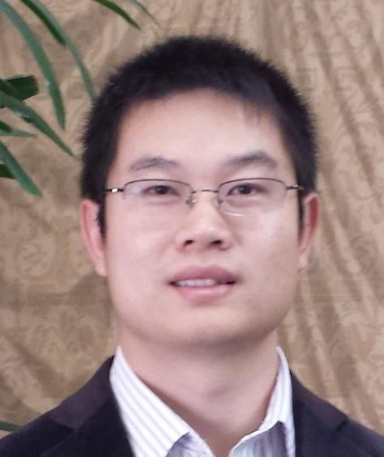
Dr. Dongrui Wu received a B.E in Automatic Control from the University of Science and Technology of China in 2003, an M.Eng in Electrical and Computer Engineering from the National University of Singapore in 2005, and a PhD in Electrical Engineering from the University of Southern California (USC) in 2009. He was a Research Associate in the USC Institute for Creative Technologies and Signal Analysis and Interpretation Laboratory, a Lead Research Engineer in the Machine Learning Lab, GE Global Research, Niskayuna, NY, and Chief Scientist of several startups. He is now a Professor at the School of Automation, Huazhong University of Science and Technology, Wuhan, China.
Prof. Wu's research interests include affective computing, brain-computer interface, computational intelligence, and machine learning. He has over 90 publications (4100+ Google Scholar citations, h=34), including a book “Perceptual Computing” (Wiley-IEEE, 2010). He received IEEE International Conference on Fuzzy Systems Best Student Paper Award in 2005, IEEE Computational Intelligence Society (CIS) Outstanding PhD Dissertation Award in 2012, IEEE Transactions on Fuzzy Systems Outstanding Paper Award in 2014, and North American Fuzzy Information Processing Society (NAFIPS) Early Career Award in 2014. He was a finalist of IEEE Transactions on Affective Computing Most Influential Paper Award in 2015, and IEEE Brain Initiative Best Paper Award in 2016.
Prof. Wu is an Associate Editor of IEEE Transactions on Fuzzy Systems (2011-), IEEE Transactions on Human-Machine Systems (2014-), and IEEE Computational Intelligence Magazine (2017-). He was the lead Guest Editor of the IEEE Computational Intelligence Magazine Special Issue on Computational Intelligence and Affective Computing, and the lead Guest Editor of the IEEE Transactions on Fuzzy Systems Special Issue on Brain Computer Interface. He is a Senior Member of IEEE, an Executive Committee member of the Association for the Advancement of Affective Computing (AAAC), a Board member of the NAFIPS, and a member of IEEE Systems, Man and Cybernetics Society Brain-Machine Interface Systems Technical Committee, IEEE CIS Fuzzy Systems Technical Committee, Emergent Technologies Technical Committee, and Intelligent Systems Applications Technical Committee. He has been Chair/Vice Chair of the IEEE CIS Affective Computing Task Force since 2012.

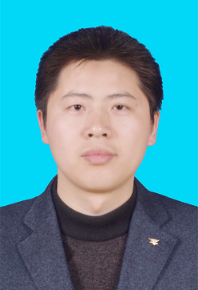
Dr. Zhaohong Deng received a Ph.D. degree in industry information technology and engineering from Jiangnan University, Wuxi, China, in 2008. He is currently a Professor in the School of Digital Media, Jiangnan University. His current research interests include uncertain and interpretable intelligent model, fuzzy systems, neural computing, and their applications in biochemical process modeling and biomedical signal processing. He is an Associate Editor of five international journals including Neurocomputing and PLOS ONE. He has published over 100 papers in international/national journals, including 22 papers in ACM/IEEE Transactions.

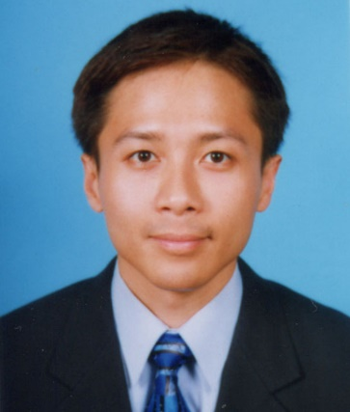
Dr. CHOI Kup-Sze (Thomas) received a B.Sc.(Hons) degree in Applied Physics, an M.Phil. degree in Electronic Engineering and a Ph.D. degree in Computer Science and Engineering. He is currently an Associate Professor of the School of Nursing, The Hong Kong Polytechnic University, as well as the Director of the Centre for Smart Health and the PolyU-Henry G. Leong Mobile Integrative Health Centre. Thomas has been engaging in multidisciplinary research in health care since 2000. His research interests include virtual reality and artificial intelligence, developing healthcare innovations in medicine, nursing and rehabilitation. His invention of haptic platform for occupational rehabilitation won a silver medal in the 42nd International Exhibition of Innovations of Geneva, Switzerland, 2014. He has recently started a new line of research in electroencephalography and brain-computer, aiming to capitalize on the technologies of virtual reality, haptics and machine learning to develop practical applications for health care purposes.

